

A PROJECT ON BASIC
HOTEL MESSAGE MANAGEMENT

SUBMITTED BY:
PILLAI GANESH JAYARAJAN (ROLL NO.47)
ROHIT SRINIVASAN (ROLL NO. )
SAWKAR POOJA PRASANNA (ROLL NO. )

SUBMISSION DATE:

UNDER THE GUIDANCE OF Miss. SHAILEJA


SARASWATI EDUCATION SOCIETY’S
SARASWATI COLLEGE OF ENGINEERING
(Approved byAICTE,recg. By MaharashtraGovt.DTE.Affliated to Mumbai Univesity)

PLOT NO.46/46A, SECTOR NO.5, BEHIND M.S.E.B SUBSTATION, KHARGHAR, NAVI MUMBAI-410210

CERTIFICATE

This is to certify that the requirements for the project
entitled “Basic Hotel Message Management”.

Have been successfully completed by the following students:
1) Pillai Ganesh Jayarajan (47)
2) Rohit Srinivasan ()
3) Sawkar Pooja Prasanna ()

In partial fulfillment of Sem-V, Bachelor of Engineering
Of Mumbai University in Computer Engineering of
Saraswati College Of Engineering, Kharghar
during the academic year 2011-12 for the subject
“Advanced Database Management Systems”

H.O.D. PRINCIPAL

PREFACE

Now-a-days life has almost become impossible to function without Computers & Info-Tech. tools. These facts make the use of computers in each and every field, may it be Govt. Offices, Medical Research, Hospitability etc.

Internet has become a popular technique to spread information across the globe. Although internet is a new concept in India, now-a-days it has achieved great popularities and is an appropriate way to convey our message and ideas to others.

Now for getting in hotel nearest place or the far place, all we think about is getting a good restaurant . Pogaro Hotels ltd has its own branches all over the world with more than 300 branches available. Has we look over the population, there are no more empty seats found to be filled at time of getting into a restaurant . There are many restaurants and hotels which get filled and many times we see population sitting in line just waiting for the seats.There are various medium through which we get into booking the seats in future .

Pogaro also has the medium of getting into such booking in advance by internet as a medium. It’s a basic mode were we can send message to the administration and in reply from administration we get a call according to the local area near by.

All we need to get register as a member and use the advantage of messaging booking .

TABLE OF CONTENTS

INDEX

Sr No. | Contents | Page No.
1. | Introduction | 5
2. | Technology And Hardware Used | 6-7
3. | Uploading Method | 8
4. | SiteMap | 9
5. | Details Of DataBase | 10-11
6. | Relationship Diagram | 12
7. | Maintainance And Upgradation | 13
8. | Future Enhancement | 13
9. | Screen Shots | 13-16
10. | BiblioGraphy | 17

INTRODUCTION

Usually there are number of people travelling all over the world and for them its this hotel kind which helps them to book there room for stay in advance or simply getting a dinner table This site is developed for the people who are interested in booking seats of hotel as in the same manner which is followed in booking tickets for a movie in advance . .

Purpose of the Site:
The site www.pogaro.co.nr is an attractive Website. The purpose of this site is to provide information about various branches of Pogaro Hotels The user first of all needs to become a member of the site and just message the admin of the company which is handled directly through the net itself. There are many admins all over handling at each branches so that we can access the member as soon as the message is sent and we let them know the status of the availability of seats aand other queries sent by the member.

Features of using this site:

>>> User Satisfaction:
This site provides all the information related to fields without much effort. Hence, users are satisfied with the site.

>>> Easy Mode of Information messaging:
User can easily message as per the member’s convenience. There is no such rule or any criteria for sending message.
.

>>> Easy Navigation:
Appropriate links are provided for easy navigation for the user through the site.
TECHNOLOGIES USED

Hardware Used: -

Processor Type : Pentium IV 857 MHz

RAM : 256 MB

Server side Database Used:
Wampserver is usedwhich includes all my sql and php for handling this project.

Scripting Language Used: -
For Developing web front page we used html along with javascript

HTML (Hyper Text Markup Language): -

HTML is a document-layout and hyperlink specification language. It defines the syntax and placement of special, embedded directions that aren’t displayed by the browser, but tell it how to display the contents of the document, including text, images, and other support media.
The language also tells you how to make a document interactive through special hypertext links, which connect your document with other documents - on either your computer or someone else’s, as well as with other Internet resources, like FTP and Gopher.

JavaScript Language: -

JavaScript enables you to embed commands in an HTML page.
When a compatible Web browser, such as Netscape Navigator 2 or higher or Internet Explorer 3 or higher, downloads the page, the Web browser as a part of the HTML document loads your JavaScript commands.
These commands can be triggered when the user clicks page items, manipulates gadgets and fields in an HTML form, or moves through the page history list.
JavaScript provides a fairly complete set of built-in functions and commands, enabling you to perform math calculations, manipulate strings, play sounds, open new windows and new URLs, and access and verify user input to your Web forms.

CSS (Cascading Style Sheet): -

Cascading Style Sheets offer separate means of controlling the display of Web pages, with the intent of resorting HTML to its original structural purpose.
They are collections of style information that are applied to plain text.
Internal and inline style sheets are used in this site.
All the style information are embedded within the <style>...</style> tags inside the <head>...</head> tags and also included in the specific tags.

SQL (Structured Query Language): -

An SQL language is used to build queries while inserting and retrieving records from databases.

URL OF THE SITE

The URL proposed for this site is: http://localhost/main.html

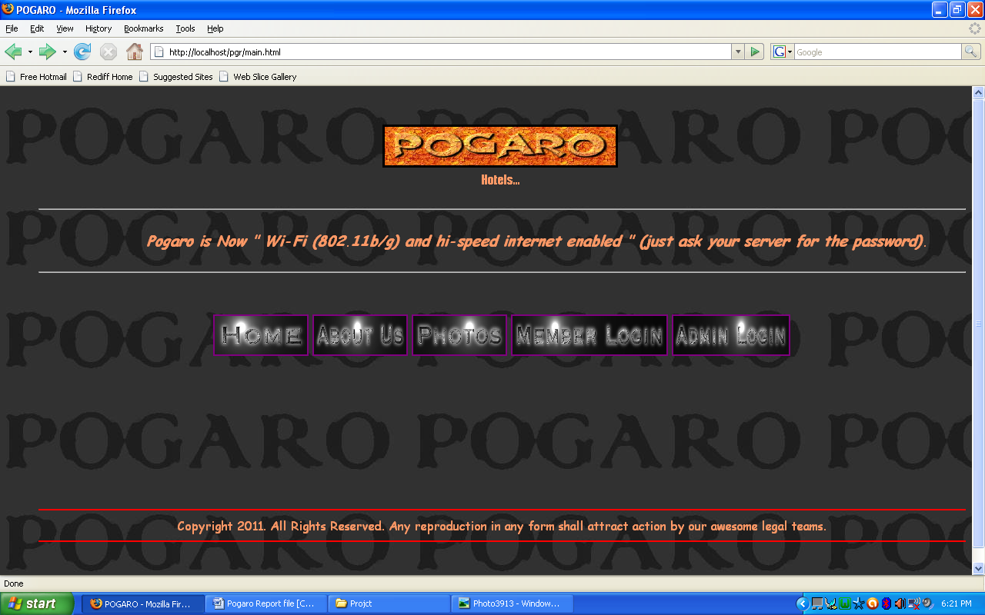

UPLOADING METHODS

This site would be uploaded using “HTTP” .It is the software used to upload a site.

After building a web site we need to host it so that everyone can view it. This requires uploading the website to the server.
Many different methods exists for uploading a web site. Here we discuss a few of these.

1) The simplest way to upload web site to your hosting accounts is to
Use an FTP (file transfer protocol) program.
An FTP program simply provides you with an easy way to select files on your computers Hard Drive, and copy them over to your hosting account. An FTP program will typically show two windows;
One providing a view of your computer and one that shows files and folders in your hosting account on the server. To upload your web pages and other associated image files in your hosting account you have to select the
Files and folders you want to upload from your computer in your computer window and then drag and drop them over to the server window essentially copying them to server. Cuteftp7.0 is one of the examples for performing the above mentioned task.

2) If the web site is made using Front Page then you will need the front page Server Extensions installed in your hosting accounts. In such a case one does not use FTP method of uploading files.
To upload your front page build web site to your hosting accounts first make sure the front page Server Extensions are installed then simply click on Publish button then enter URL .You will then prompted for user name & password which you will get from you web hosting provider, Once you enter those your web site files and folders will all be copied to your hosting accounts.

SITE MAP

SITEMAP:-

A map is an image that graphically represents the location of various elements within a set region or space. A Site Map shows pages generally related by structural proximity.
Access to a Site Map should be from every page of the web site. The Home page of the website shows the main links of the Website. These links take the user to the respective elements.

This web site follows the Web Structure which offers links to and from every page in the site. This allows the user to jump freely to any page from any other page. In this web site on each page clear location information is added and standard navigation bar that not only tells the user where they are but where they can go is also provided.

DETAILS OF THE DATABASE USED

Table Name : member

This table is used to store the member login criteria

Structure of Table

Sr No. | Field Name | Description | Data Type
1 | myusername | Username | Text
2 | mypassword | Password of User | Text

Table Name : memberinfo

This table is used to store the registered details of the member.

Structure of Table

Sr No. | Field Name | Description | Data Type
1 | myusername | Username | Text
2 | mypassword | Password of User | Text
3 | mymobile | Mobile number | Text
4 | mystate | State | Text
5 | mycountry | Country | Text
6 | myemail | Email | Text

Table Name : msg

This table is used to store the massageof the members registered.

Structure of Table

Sr No. | Field Name | Description | Data Type
1 | myusername | Username | Text
2 | mypassword | Password of User | Text

Table Name : admin

This table is used only for the administrators login .

Structure of Table

Sr No. | Field Name | Description | Data Type
1 | myadminname | Admin User name | Text
2 | mypassword | Password of Admin | Text

Consist of
Main
Admin Login
Member?
Apply

Can Read
Password
POGARO
memberinfo
Login
Message
NO
Logout

User Id
YES
myadminname

myusername
mypassword

mypassword

mymobile

mystate
myusername
mycountry

myemail
mymessage

After Submit

MAINTENANCE AND UPGRADING THE WEBSITE

The carrer tec section will be updated every week, so that the users of this website are availed latest information along with advanced booking system technology..

FUTURE ENHANCEMENTS

Future Enhancements: -

In future I would like to bring some modifications in my site.
External links would be provided to get information about various other map fields and can get your route easily to our branches over the internet. As online we would be able to have expansion over ordering and parcel within hours.

SCREEN SHOTS

Main page:

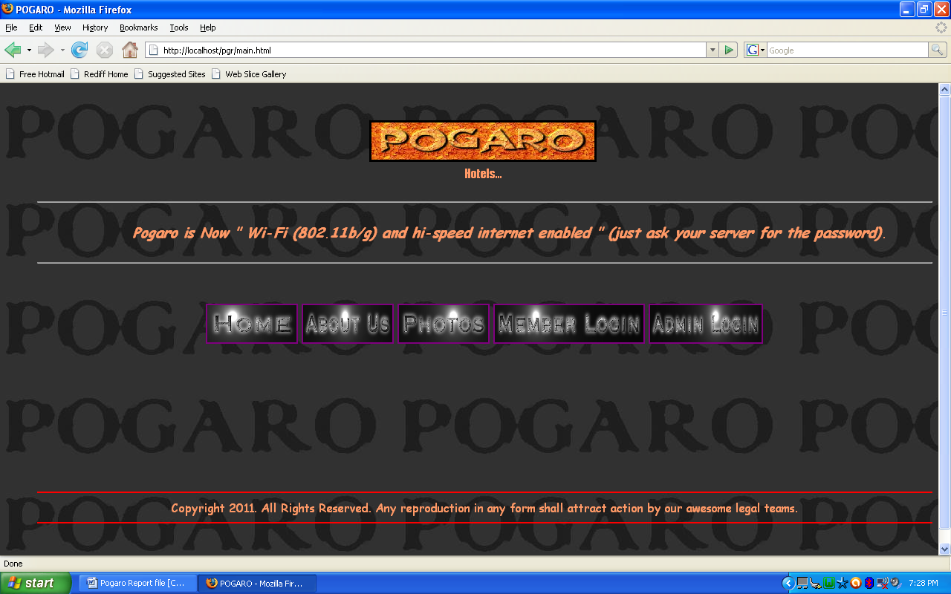

About us page
;
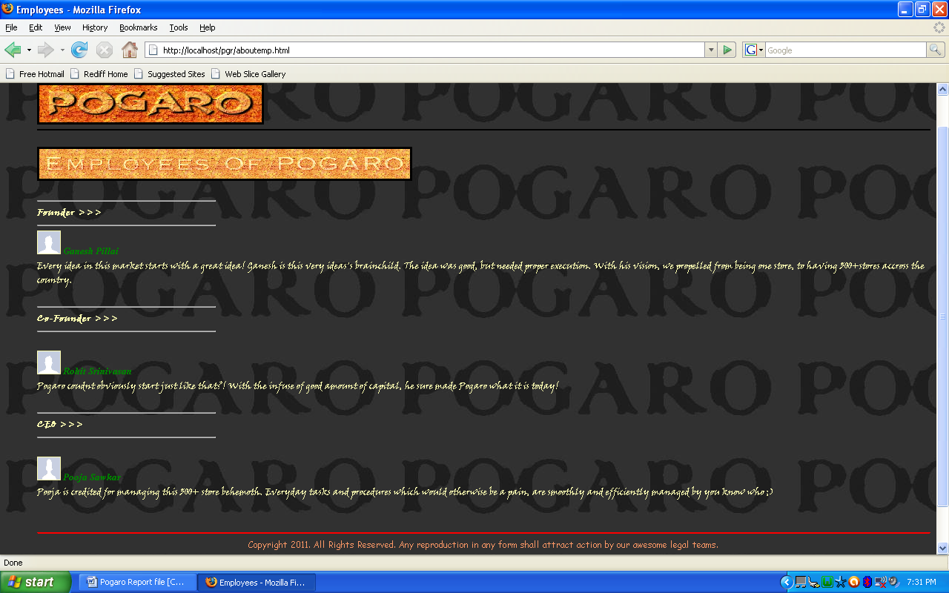

Member Login page;

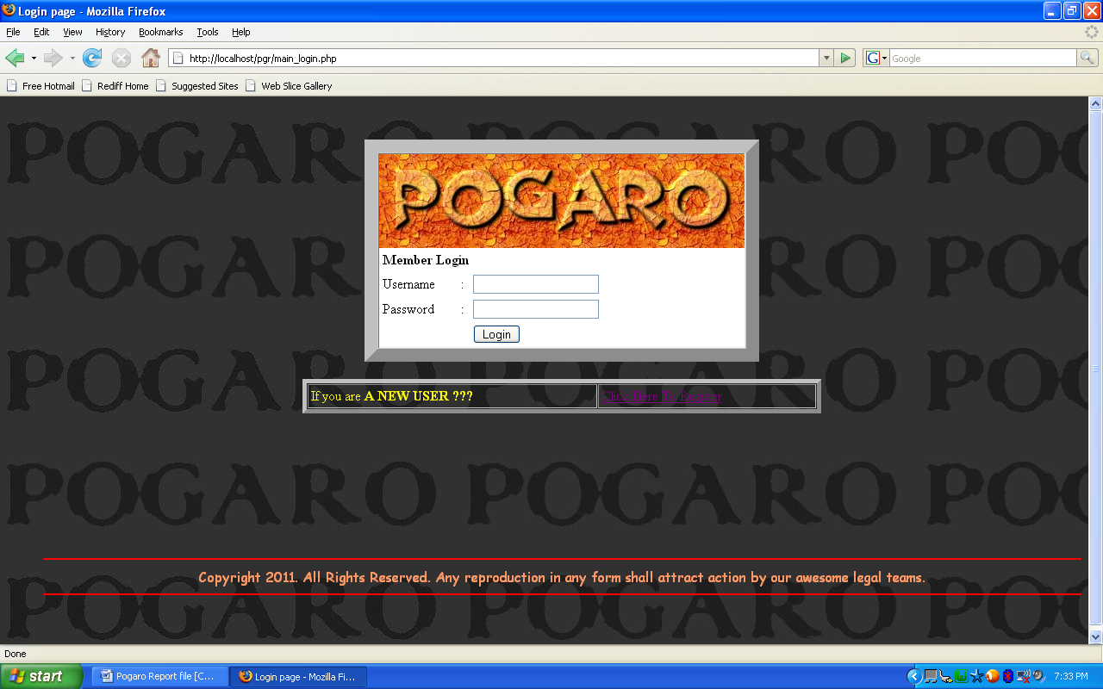

New User Registration page;

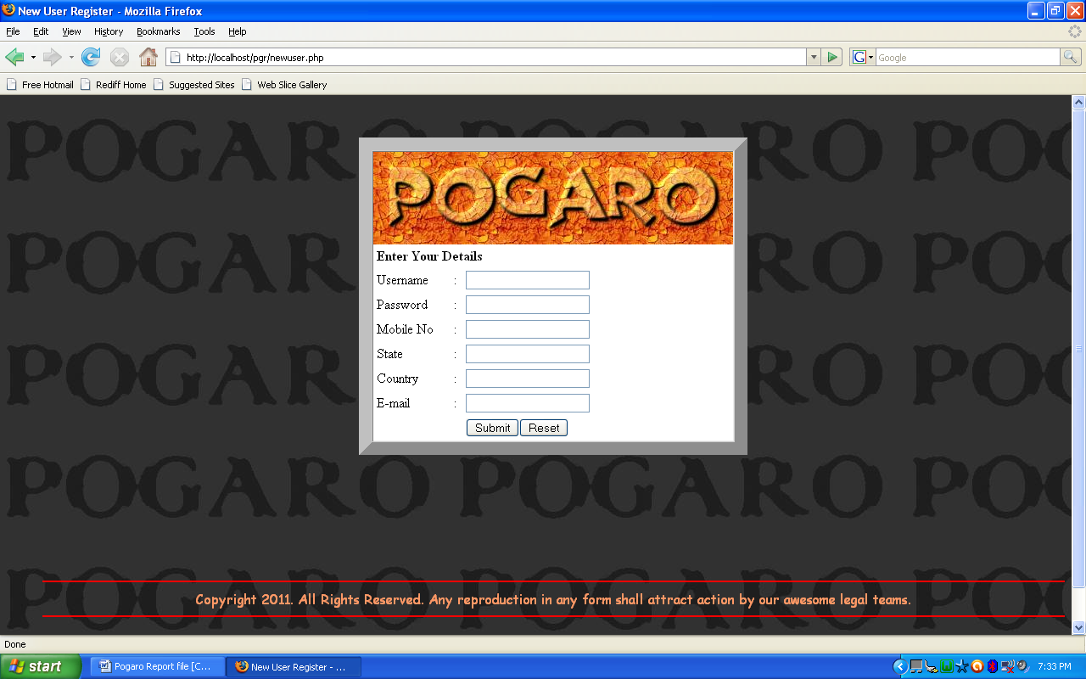

About us page;

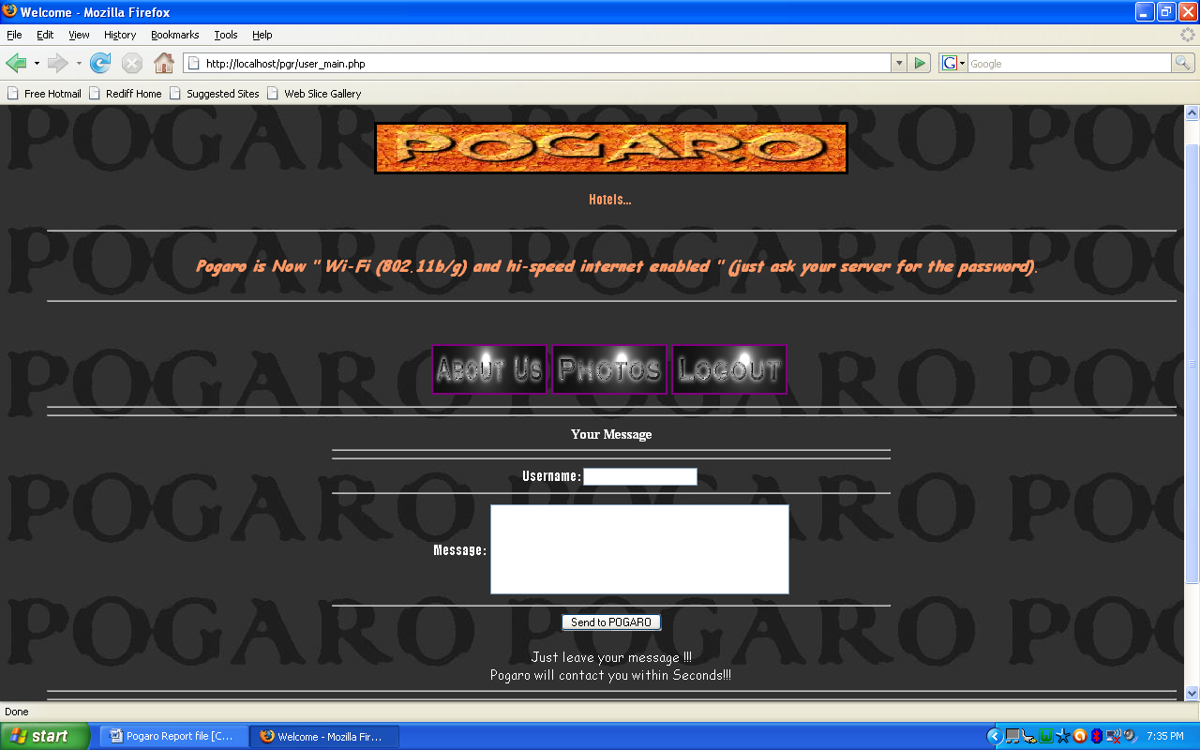

Administrators page for managing the messages from member;

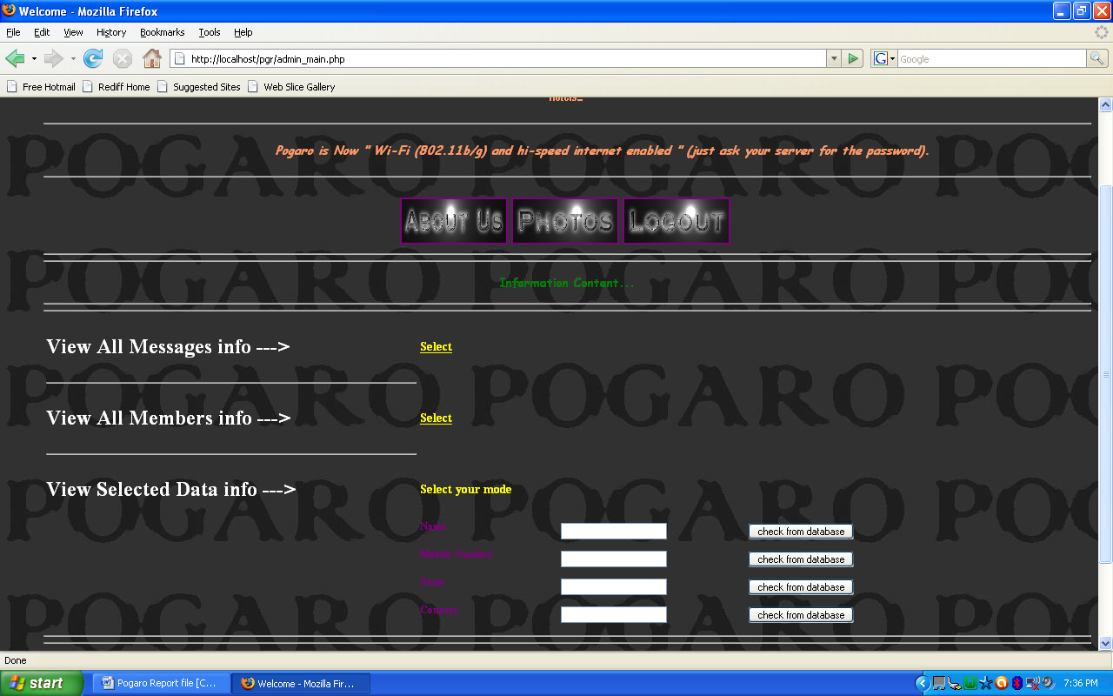

Conclusion;
We have successfully created a project on web & database.
The project uses Wampserver2 as the base with mysql database connectivity by html scripts and php.

BIBLIOGRAPHY

References:

Html Black Book Steven Holzner

Websites:

www.w3schools.com/php/
www.w3schools.com/html/
php.net/manual/en/tutorial.php

THANK YOU

